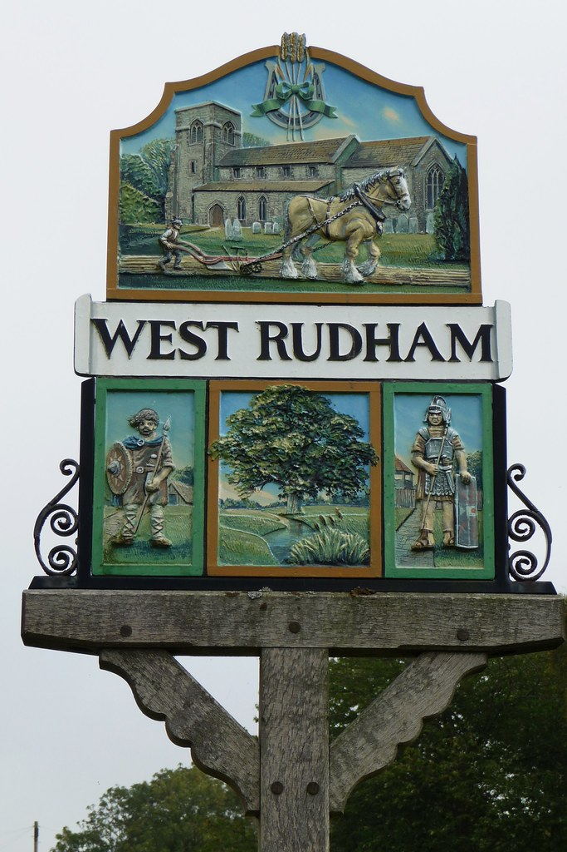

West Rudham Parish Council

Data Protection Privacy Notice

1. Background

This privacy notice lets you know what happens to any personal data that you give to us, or any that we may collect from or about you. It applies to all services and activities where we collect your personal data. This privacy notice applies to personal information processed by or on behalf of the Parish Council, as defined by the General Data Protection Regulation (GDPR) 2018.

Changes to this privacy notice.

We may change this privacy notice from time to time by updating this page in order to reflect changes in the law and/or our privacy practices. We encourage you to check this privacy notice for changes whenever you visit our website.

The Parish Council and our Data Protection Officer.

West Rudham Parish Council is the data controller of your personal data. We have a Data Protection Officer (DPO) who is responsible for data protection compliance. You can contact the DPO using the details below.

2. What kinds of personal information about you do we process?

Personal information that we will process includes:

• Personal and contact details (e.g. title, name, addresses, phone numbers)
• Details of family members (e.g. burial records)
• Copies of correspondence between you and the Council (e.g. emails you have sent us)
• Services you receive from us, as well as have been interested in and have received, and the associated payment methods used (e.g. allotment records)
• Services and goods you provide to us, (e.g. as a sole trader)
• Employment details (if you apply for a job with or are employed by the Council)

3. What is the source of your personal information?

We’ll collect personal information from the following general sources:

• From you directly (e.g. allotment holders, employment information)
• From your family members (e.g. in relation to burial records)

4. What do we use your personal data for?

We use your personal data, including any of the personal data listed in section 2 above, for the following purposes:

• To respond to a request for a service or manage services that we provide to you (or you provide for us, e.g. as a contractor)
• To monitor and record our communications with you and our staff (see below)
• To comply with legal and regulatory obligations, requirements and guidance
• To assess job applications or to manage existing staff employment
• To process applications for grants, or to become a councillor
• To carry out our public duties and tasks

We will never use your personal information for purposes other than those for which it was provided or obtained without first obtaining your consent.

5. What are the legal grounds for our processing of your personal information (including when we share it with others)?

We rely on the following legal bases to use your personal data:

• Where it is needed to provide you with services, such as processing requests for information or services that you make to the Council, or providing services to you (such as an allotment or burial plot for a family member), and at all stages and activities relevant to managing services provided to you
• To comply with our legal obligations
• For a public task, such as performing a task in the public interest or for our official functions, where the task or function has a clear basis in law
• With your consent, such as when you have given us clear consent to process your data for a specific purpose

6. When do we share your personal information with other organisations?

We may share information with the following third parties for the purposes listed above:

• Governmental and regulatory bodies, e.g. the District or County Council
• Other organisations and businesses who provide services to us such as back-up and email hosting providers, IT software and maintenance providers, document storage providers and suppliers of other back office functions
• Our bank (e.g. for making payments to you)
• Our auditors

7. How and when can you withdraw your consent?

Where we rely on your consent to process personal data, you can withdraw this at any time by contacting us using the details below, or via our website.

8. Is your personal information transferred outside the UK or the EEA?

We are based in the UK but sometimes your personal information may be transferred outside the European Economic Area. If we do so we’ll make sure that suitable safeguards are in place, for example by using approved contractual agreements, unless certain exceptions apply.

9. What should you do if your personal information changes?

You should tell us so that we can update our records using the contact details below or via our website. We will then update your records if we can.

10. For how long is your personal information retained by us?

Unless we explain otherwise to you, we will hold your personal information based on the following criteria:

• For as long as we are required to in line with legal and regulatory requirements or guidance
• For as long as we have reasonable needs, such as managing our relationship with you and managing our work
• For as long as we provide services to you

You can refer to our Information Audit for further detail on this.

11. What are your rights under data protection laws?

Here is a list of the rights that all individuals have under data protection laws. They don’t apply in all circumstances. If you wish to use any of them, we’ll explain at that time if they are appropriate or not.

• The right to be informed about the processing of your personal information
• The right to have your personal information corrected if it is inaccurate and to have incomplete personal information completed
• The right to object to processing of your personal information
• The right to restrict processing of your personal information
• The right to have your personal information erased (the “right to be forgotten”)
• The right to request access to your personal information and to obtain information about how we process it
• The right to move, copy or transfer your personal information (“data portability”)

You have the right to complain to the Information Commissioner’s Office which enforces data protection laws: https://ico.org.uk/

Contact Us

If you have any questions about this privacy notice, or if you wish to exercise your rights or contact the DPO, you can do so via our website’s Contact Us page or via email to westrudhampc@gmail.com. Alternatively, you can write to the Data Protection Officer at West Rudham Parish Council, 52 Queens Road, Fakenham, NR21 8DB.

Adopted: March 2020
Review date: March 2024

